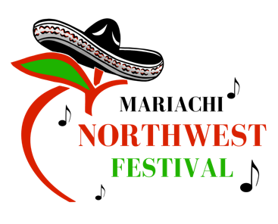

Scholarship Application Form
Mariachi Northwest Festival 2024

Scholarship/School you are applying for

Student Information

Full Legal Name
Current School
Social Security Number
Phone Number
Home Address
Parent/Guardian Name(s)

College Plans

What school do you plan to attend?
What is your field of study?
Briefly, state your educational plans

Extracurricular Activities

Positions of leadership:
School, community, or church activities:

Essay Questions

Describe your goals: personal, educational and career. (300 words max)

Identify any obstacles (financial hardships, mobility, late entry, early withdrawal, language or cultural barriers) that you have overcome to be a successful student. (300 words max)

How has Mariachi program impacted your life? And, what would you be willing to do to keep Mariachi alive in our community for the younger generations? (300 words max)

Needs Statement: Please explain how this scholarship will be beneficial to your educational career. (300 words max)

